If you have never recorded a video before, it may seem intimidating. It is something that you will get used to. I’m going to try to outline the steps here, though how the various screenshots look on your computer might be different than mine.

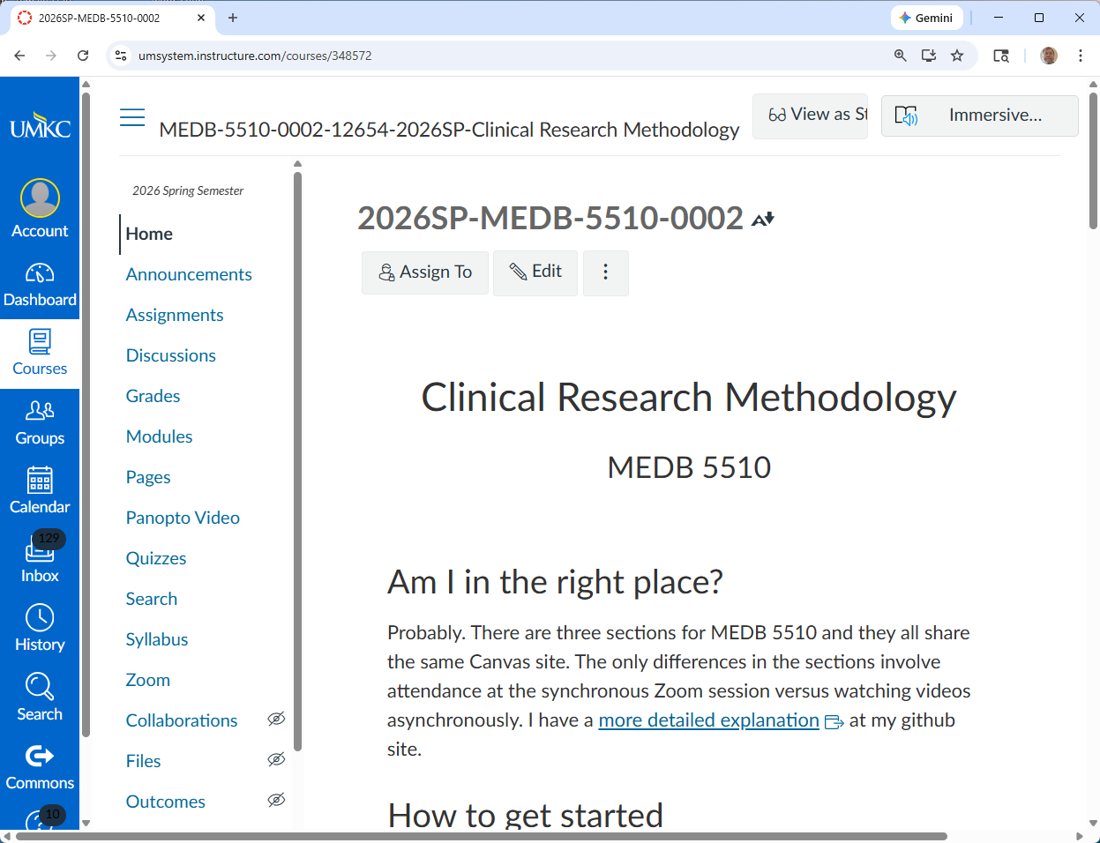

If you do not have any special software on your system to record videos, click on the Panopto link.

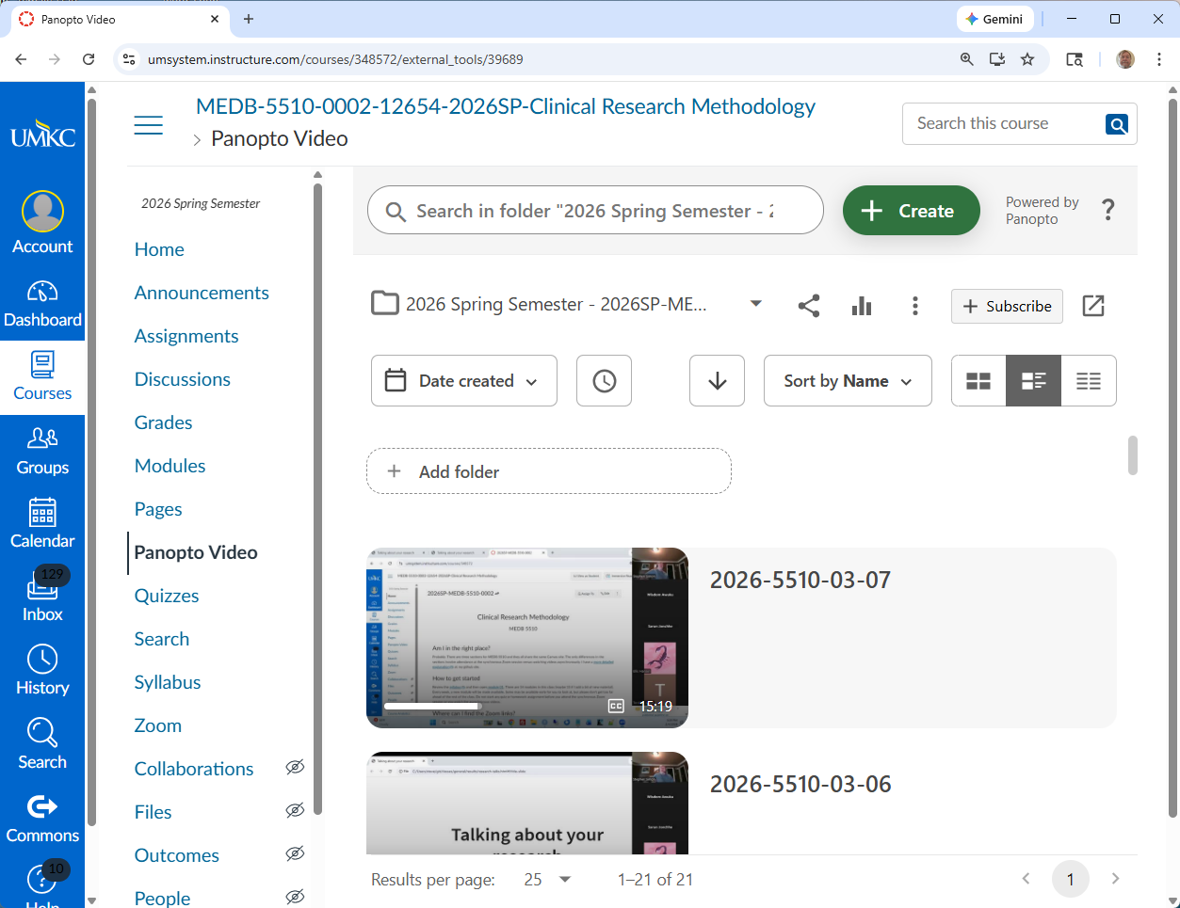

Find and click on the Create button.

You will see several choices.

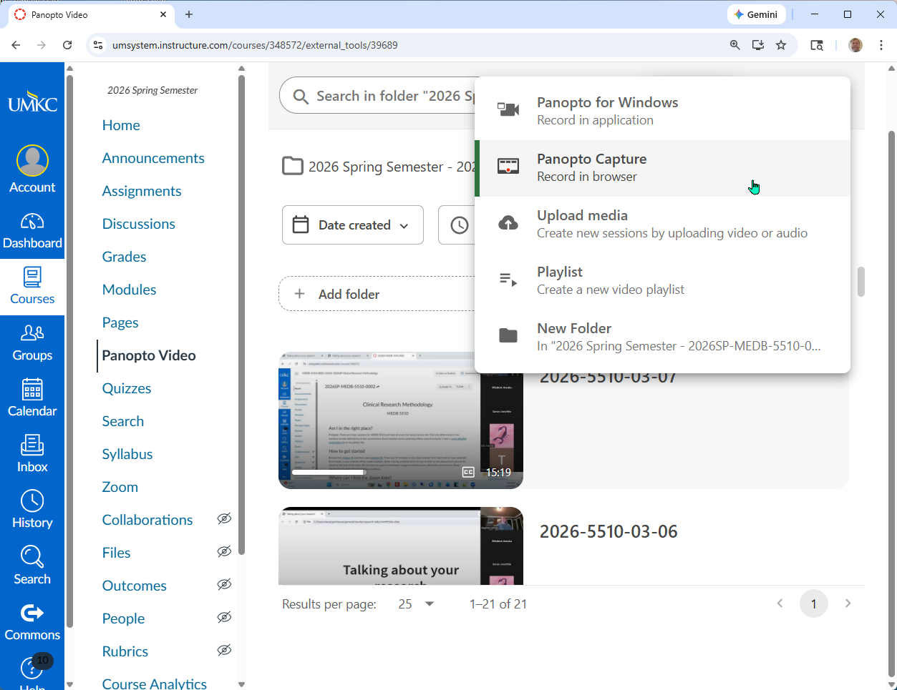

I use Panopto for Windows, but that may not be available on your system. If so, click on Panopto Capture.

You should see your smiling face on the screen. I don’t want to see that, I want to see your slides.

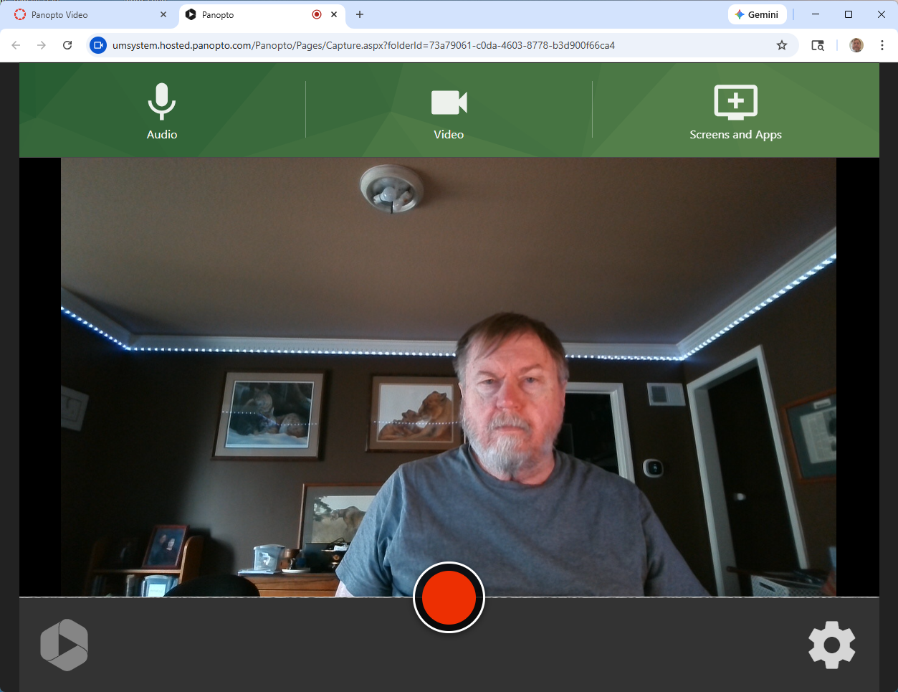

Click on Screens and Apps.

Find the tab that represents your presentation. For me, it is video00-overview.pptx

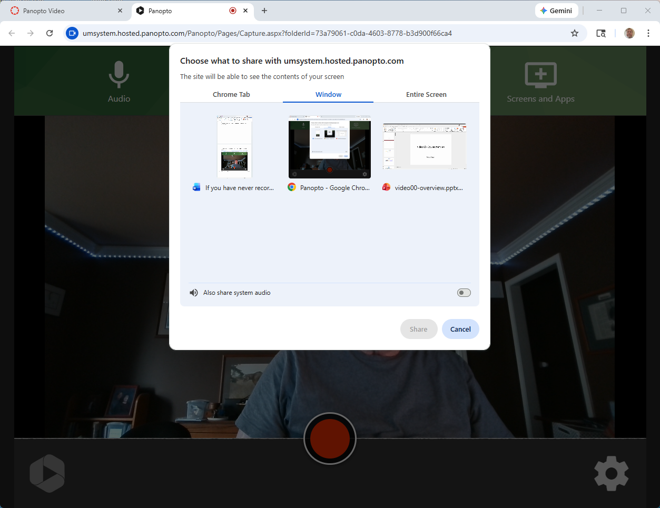

As handsome as I am, I still think it is a good idea to turn off my camera and record only the Powerpoint slides. Hover over your image.

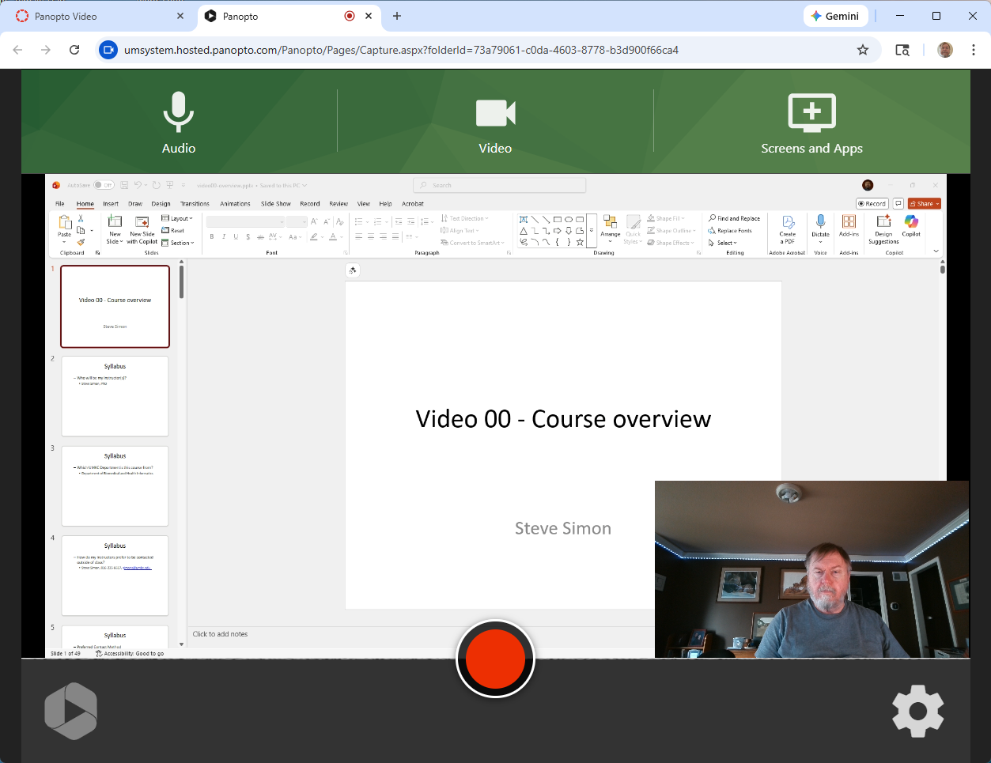

Click on the X to banish the video camera.

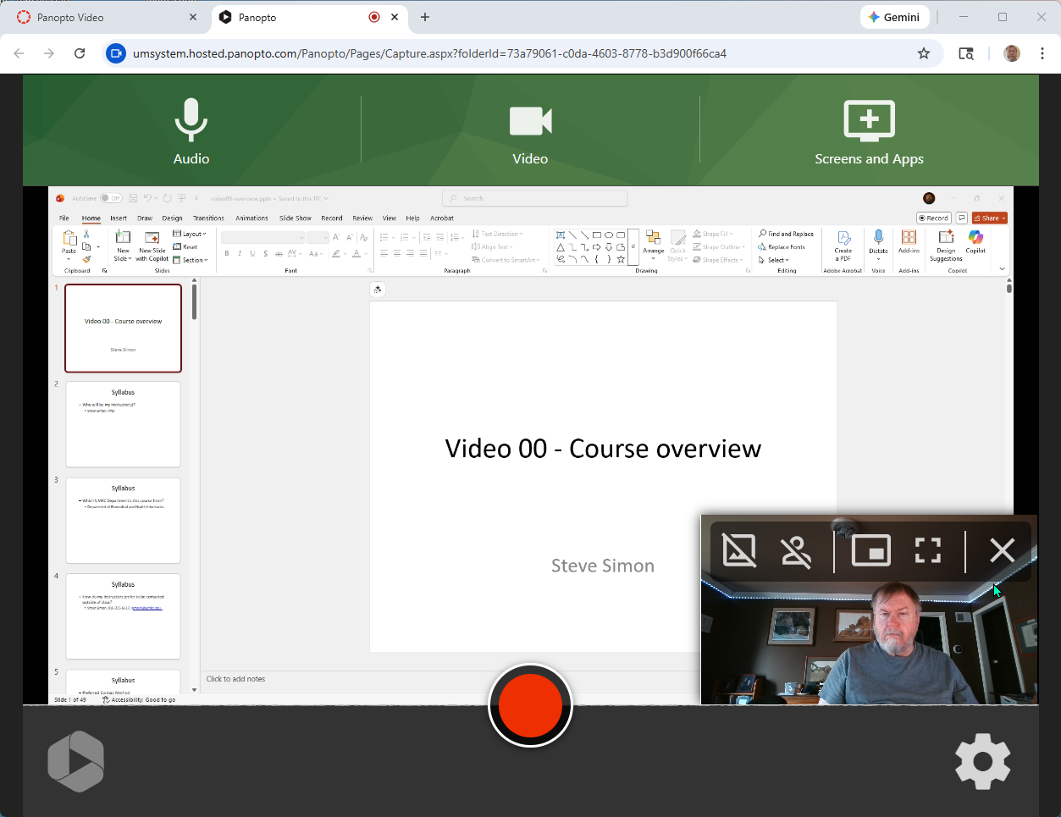

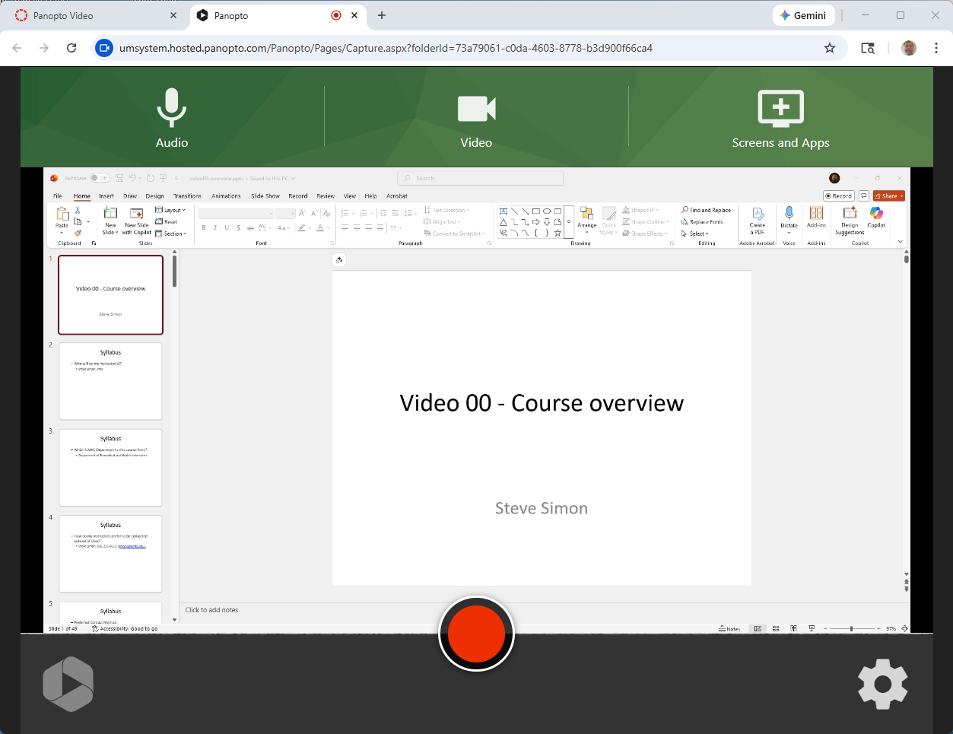

Expand to full screen.

